Introduction

This document describes the procedure for patching mirrored servers. The goal is to ensure minimal downtime.

The details of the system are as follows:

Primary Database Server: DMS-S8MP-2SQL

Secondary Database Server: DMS-S8MP-3SQL

Please note that the roles will switch once you perform a failover.

Procedure

1. Make sure the service pack executable is located on both servers.
2. Take stock of which databases are mirrored.
3. If there is a witness, make sure it is online, if it’s not online either remove the witness or fix the witness server. If you do not, it will bring them both down.
4. Also ensure there are no database snapshots created. If there are, determine the purpose from application and support teams before you proceed.
5. Log on to primary (DMS-S8MP-2SQL) and suspend mirroring.
   1. Run the following command for each mirrored database
   2. Alter database <database_name> set partner suspend
   3. Verify from screen shot that the databases all display “principal, suspended”

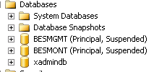

1. Log on to the Secondary Server (DMS-S8MP-3SQL) and Patch
   1. Backup system databases
   2. Copy mssqlsystemresources to a backup location
   3. Stop SQL server services
   4. Install patch
   5. Reboot
2. Go back to the principal server and resume mirroring

Alter database <database_name> set partner resume

Check that the primary displays “Principal synchronized”. If not, wait till it does.

In the following screenshot, DMS-s8mp-2sql is the principal and DMS-S8MP-3SQL is the Mirror. Notice that the mirror now has the higher number, which is the official version number.

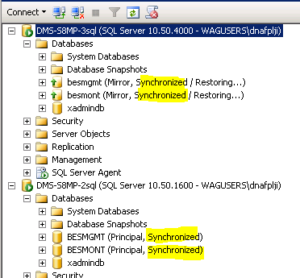

Figure 1 Synchronized after Patch

1. Failover to the secondary server

On the primary, for each mirrored database run the following command

Alter database <database_name> set partner failover

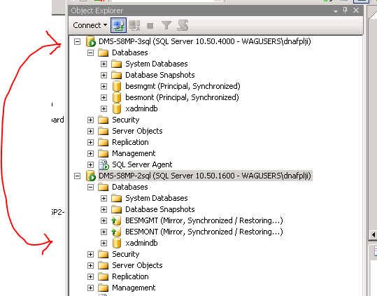

Figure 2 after Failover

Verify that the failover is complete. You could now see that the roles have switched. DMS-S8MP-3SQL is now the primary

1. Repeat steps 5 and 6 For the new secondary server (DMS-s8mp-2sql)

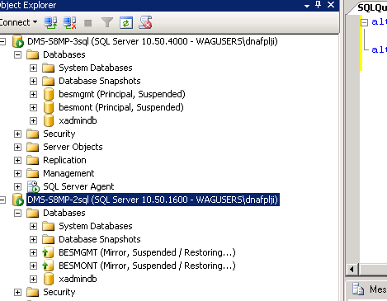

Figure 3 Suspended

1. After completion, ensure both versions match Ensure that both version numbers match.

Run the following command on each server and make sure they match.

select @@servername,

serverproperty('edition')

, serverproperty('productlevel')

, serverproperty('productversion')

, serverproperty('resourceversion')

, serverproperty('resourcelastupdatedatetime')